Buổi 3 — Architecture Styles
1. Layered Architecture
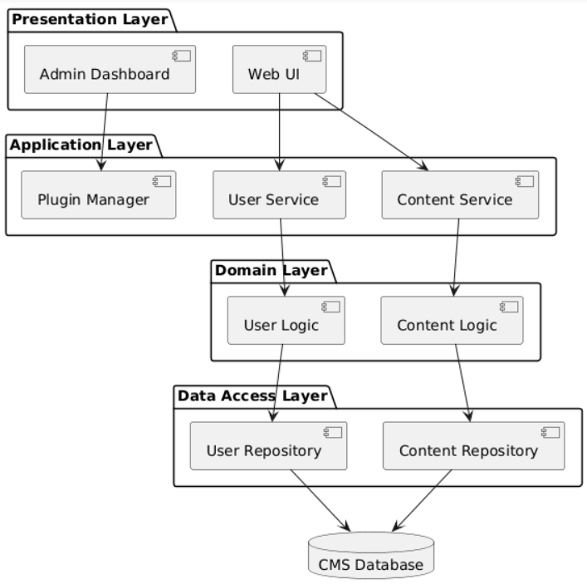

2. Microkernel Architecture
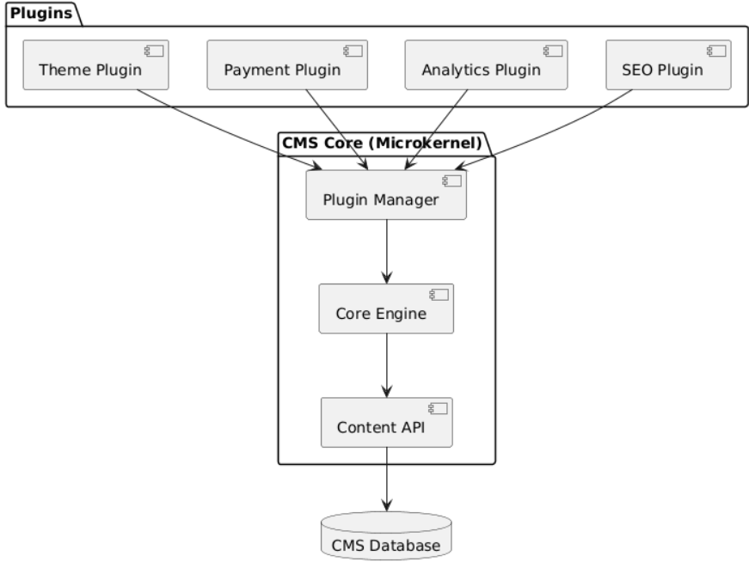

3. So sánh hai kiến trúc
Criteria | Layered | Microkernel
Extensibility | Medium | Very High
Plugin support | Poor | Excellent
Complexity | Low | Medium
Modifiability | Medium | High
Performance | Good | Good

4. Architecture Style phù hợp
Chosen: Microkernel Architecture
Lý do:
- CMS cần plugin system
- Dễ mở rộng chức năng
- Core system giữ ổn định
- Plugin có thể thêm/xóa
Ví dụ:
- SEO plugin
- Analytics plugin
- Payment plugin
- Theme plugin

